**ASSIGNMENT # 1**

**Computer Organization and Assembly Language**

***Note: Attempt all Questions by making code and output***

**Name: MUHAMMAD SULTAN**

**Student ID: 11018**

**Class ID: 107248**

**Question 01:**

Using only basic arithmetic instructions, translate the given statement into assembly Language code.

Assume A, B and C are word variables

A = B + 2 – (C*2)

**Answer to Q1**

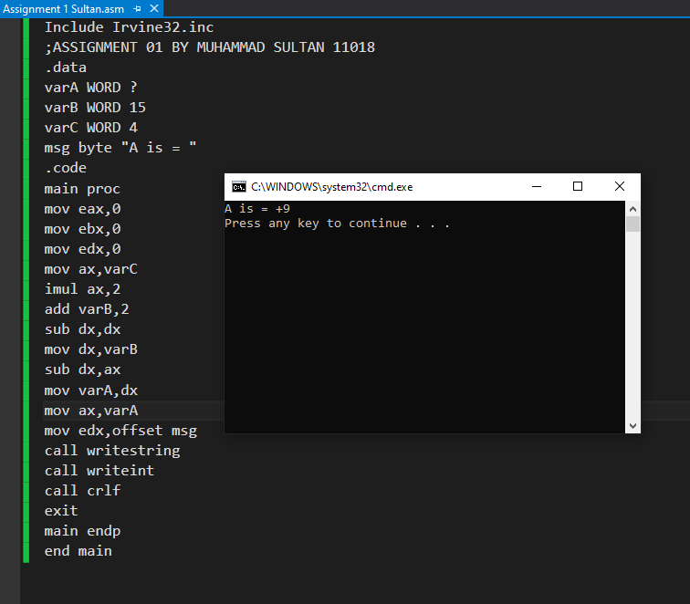

**Question 02:**

Write a program that displays the smallest and largest of five variables. The five variables are num1, num2, num3,num4 and num5 and are taken from user input.

**Answer to Q2**

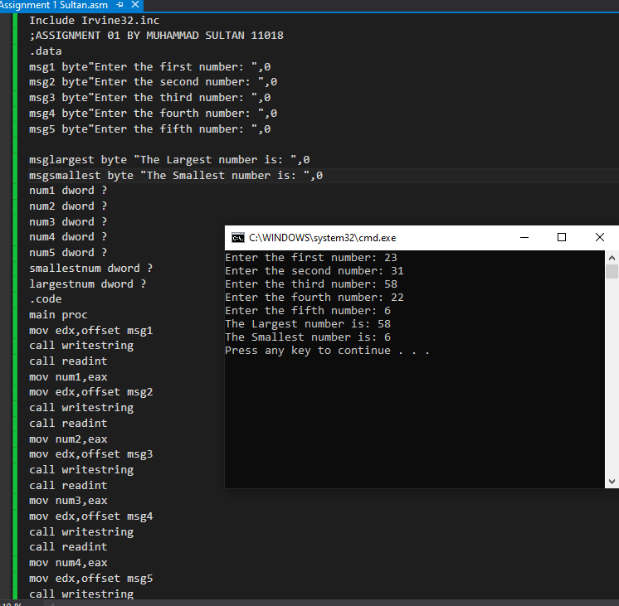

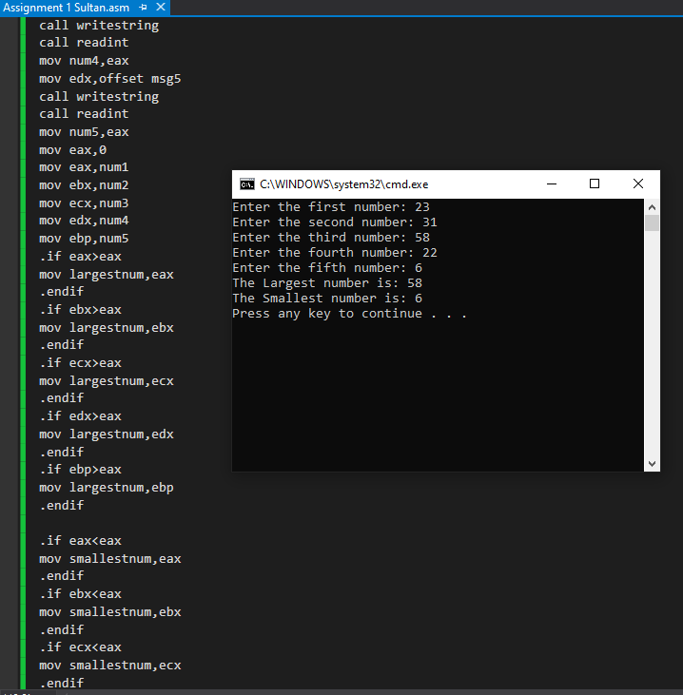

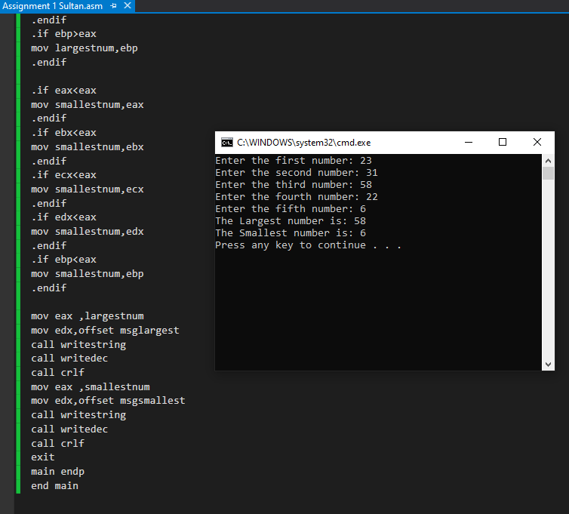

**Question 03:**

Perform the following INSTRUCTIONS on given values of registers and write FLAG values after execution.

|  |  |  |  |
| --- | --- | --- | --- |
| **AX/AL** | **BX/BL** | **INSTRUCTION** | **FLAG VALUE** |
| 02h | FFh | MUL BL | SF= 1 OF=1 ZF= 0 |
| FFFFh | 02h | DIV BL | SF=0 OF=0 ZF=1 |
| 3AD1h | AD2Bh | ADD AX,BX | SF= 1 OF= 0 ZF= 0 |

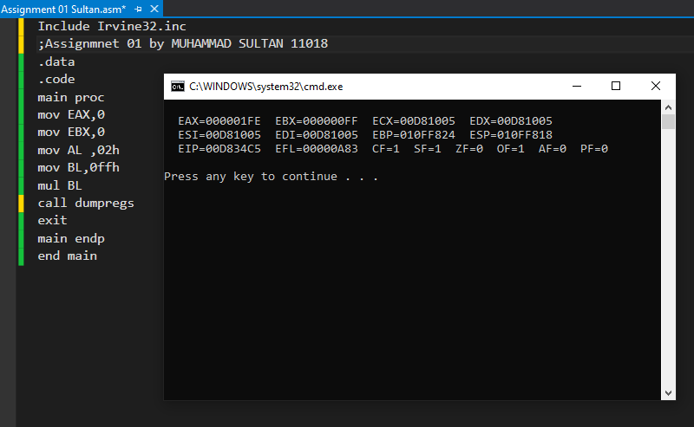

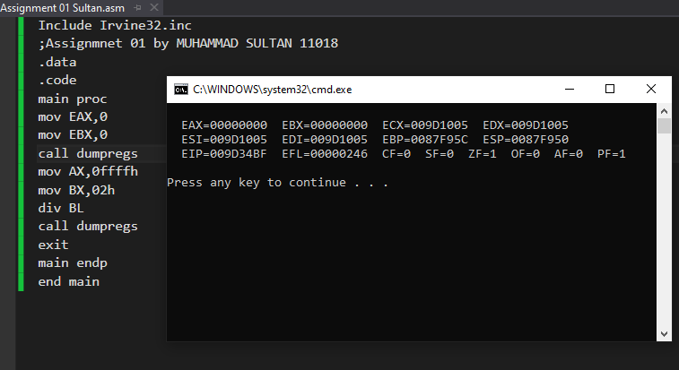

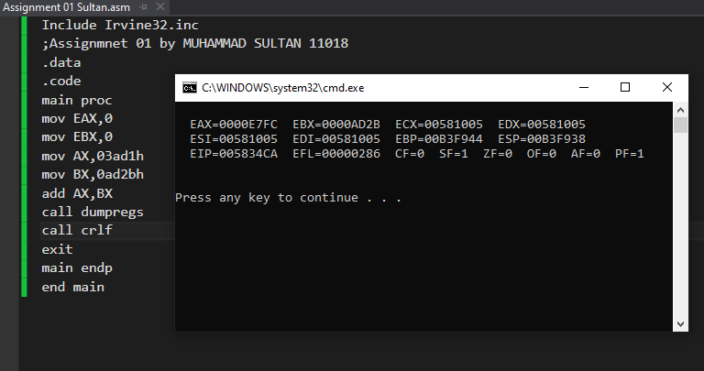

**Question 04:**

Convert below given statement into assembly language code:

IF ((X < Y) and (Z > T)) or (A > B) THEN stmt1;

**Answer to Q4**

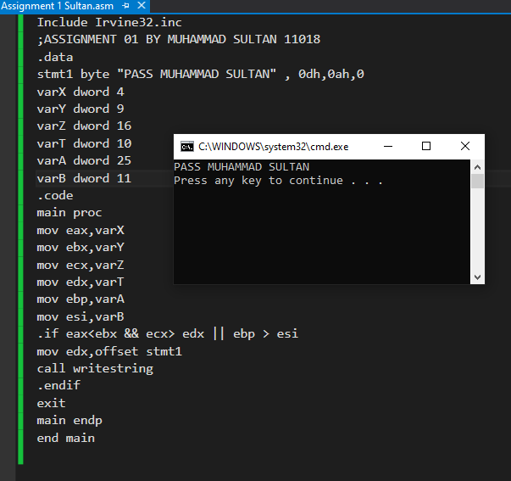

**Question 05:**

Make a program that prints a pyramid with ‘numbers’ and stearic “*” in the below given manner:

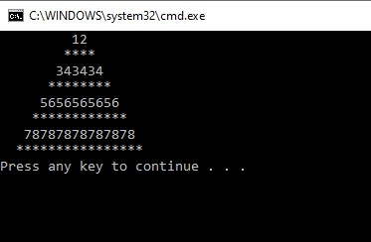

**Answer to Q5**

